Lab - Attack Analysis
Additional Note: Yellow highlighted text indicates all of my answers.
(672021159)

Objectives
Part 1: Investigate IOCs
Part 2: Investigate the Malicious Activity
Part 3: Investigate the More Malicious Activity

Introduction
Once an alert has been reported and validated, digital forensics and incident response analysis must be completed. In a large organization, members of the incident response team (i.e., CSIRT) are responsible for this process. The response team typically consists of veteran threat hunters and select cybersecurity analysts and technicians. To help the incident response team, various tools and resources are available.
In this lab, you will use the ANY.RUN online interactive malware hunting service and the Mitre ATT&CK Matrix to investigate potential malicious activity.
ANY.RUN offers a free service in which community users can upload suspected malware files for analysis. It provides a very rich set of analyses features that lets you safely investigate the behavior of malware. The ANY.RUN sandbox can dynamically run the malware and display details of what the malware does in safe and secure analysis interface.
Note: You will use the free version of ANY.RUN which has limited features and can only run malware samples on a 32-bit Windows 7 virtual machine. Two more advanced versions are available for a monthly subscription. The Searcher and Hunter versions provide access to advanced features and other operating systems (e.g., Windows 10).

Scenario
You are working as a cyber technician and you have been selected to work with the incident response team at XYZ, Inc. A cybersecurity analyst has asked you to evaluate hash values from security alerts that have been generated by the Intrusion Prevention System (IPS). The IPS has flagged a series of events as potentially malicious.
You will use the ANY.RUN online tool and Mitre ATT&CK Matrix to perform forensic analysis based on the provided hash values.

Required Resources
= A device with internet access
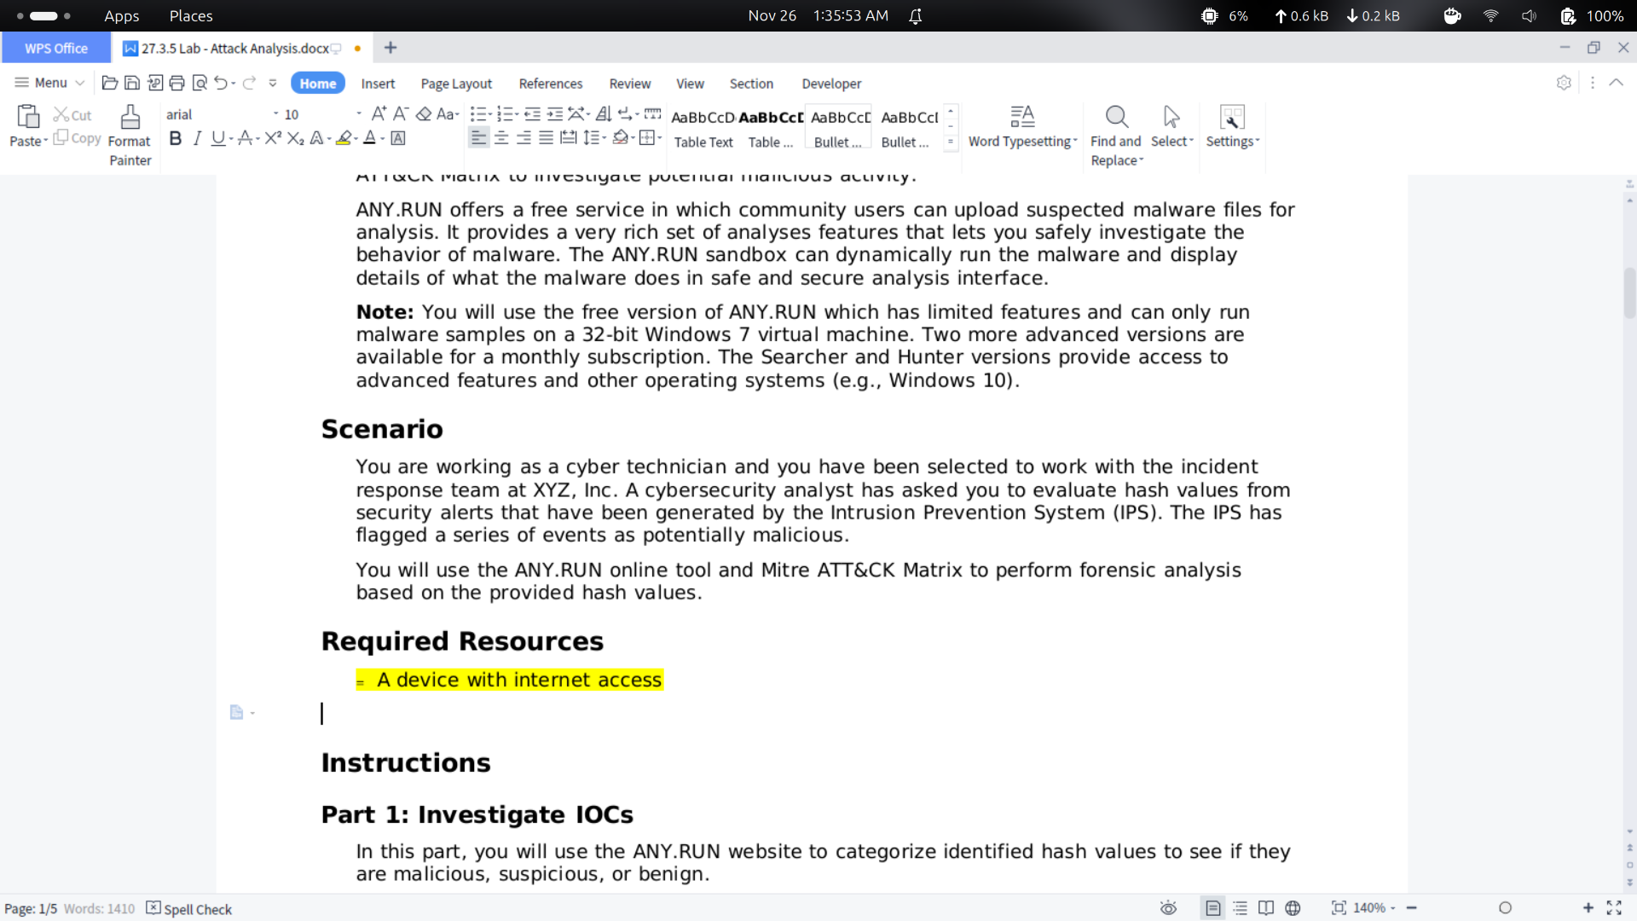

Instructions

Part 1: Investigate IOCs
In this part, you will use the ANY.RUN website to categorize identified hash values to see if they are malicious, suspicious, or benign.

Step 1: Explore the ANY.RUN site
a. Open a web browser and navigate to the ANY.RUN webpage.
b. At the top of webpage are available links starting with “WHY US”. Click SERVICE from the horizontal menu to move to the sandbox service interface.
c. Click one of the countries in the map to show the list of public submissions from that country. Community users can view a detailed analysis for each submission.
d. Explore and become familiar with this dashboard. The ANY.RUN tool has many options available that will be of great value to a cybersecurity analyst. Use this opportunity to learn more about the tool.

Step 2: Validate Suspicious Hashes
In this step, you will investigate some MD5 hash of files that the cybersecurity analyst has identified in the table below. You will verify if they are potentially malicious, suspicious, or benign.
a. To search hash values, click Public Tasks in the menu on the left.
This opens the Public submissions page which displays a list of public tasks arranged by the most recent submission. Notice that each task is labelled with the analysis verdict identifying the submission as no threat detected (i.e., benign), suspicious activity, or malicious activity.
b. The Cybersecurity analyst has asked you to validate several hash values. Complete the following table by copying and pasting the identified MD5 hash value in the search box in the upper right of the window and press Enter.
IOCs MD5 Hash Values | Malicious / Suspicious / Benign | Associated Filename
2fd03624e271ec70349ce56fb30f563b | Malicious | wireframe.exe
c419df63e0121d72411285780c2fc6cc | Suspicious | Updreg.EXE
3acf52e5a62d50bdcedcb89174bf5492 | Benign | BACs_Payment2847.html
766b774626947000e67e0b318f558e94 | Malicious | gh2st.exe
422a6ca28a7e4d8e5e498523c6f049f4 | Malicious | file1.exe
b497845beb135740e6caed03a2020036 | Suspicious | winlogon.exe
Blank Line, No additional information
Note: These malicious hash values will also be used in Part 2 and 3.
Blank Line, No additional information

Part 2: Investigate the Malicious Activity
In this part, you will use the ANY.RUN website to investigate the malicious activity identified in the previous part. From the ANY.RUN tool, you will pivot to different tools to examine the malicious activity. Finally, you will use the Mitre ATT&K Matrix to identify the tactics and techniques used by the threat actors.

Step 1: Investigate the first malicious hash process tree.
a. From the ANY.RUN Public submissions page, search for the first identified malicious hash value in Part 1, Step 2b.
b. Click the resulting entry to open it in the ANY.RUN sandbox. The ANY.RUN analysis interface provides insights to many aspects of the malware behavior.
Note: If more than one submission is displayed, then click the submission with the wireframe.exe filename.
c. On the right-hand side of the screen, you will see the process tree which displays a group of horizontal blue bars in a nested tree-like structure. It shows all the software processes that were used in the exploit. Some of them are windows software components, and others are part of the malware.
What are the names of the processes used in this activity?
Proses yang terlibat adalah wireframe.exe, cmd.exe, timeout.exe, dan NvidiaGPU.exe

Step 2: Investigate the malicious activity text report.
Above the process tree are three text boxes labelled “Text report”, “Processes graph”, and ATT&CK matrix.
a. Click the Text report to open a report in a new web browser window.
b. Scroll through the document to see the generated report.

Question:
What is the SHA256 value associated with this activity?
Nilai SHA256-nya adalah: 9C83A89EA0E56D5AF9AA37D2DABED20B2412DB8C9694A13128EA173A73557487

Step 3: Investigate the malicious activity processes graph.
a. Return to the analysis webpage and click the Processes graph.

Questions:
Which process was executed first?
Proses pertama yang berjalan adalah wireframe.exe.
What is the process name in the red highlighted box?
Nama proses di kotak merah adalah nvidiagpu.exe.
b. Click the red highlighted box.

Question:
What is the identified danger?
Bahaya yang terdeteksi adalah ASYNCRAT.

Step 4: Investigate the malicious activity in the ATT&CK matrix
a. Return to the analysis webpage and click the ATT&CK matrix to open the Mitre ATT&CK Matrix page.

Questions:
How many Tactics, Techniques, and Events are there related to this malicious activity?
Terdapat 4 tactics, 5 techniques, dan 16 events.
What are the tactics that were used by the threat actors?
Tactics yang digunakan adalah Execution, Persistence, Privilege Escalation, dan Discovery.
b. Click the various techniques that were used.

Question:
Which technique is identified as a Danger?
Teknik yang dianggap berbahaya adalah Boot or Logon Autostart Execution.

Part 3: Investigate the More Malicious Activity
In this part, you will repeat the steps in Part 2 to examine the other two malicious entries discovered in Part 1.

Step 1: Investigate the second malicious hash process tree.
a. Return to the ANY.RUN Public submissions page, and search for the second identified malicious hash value discovered in Part 1, Step 2b.
b. Click the resulting entry to open it in the ANY.RUN sandbox.

Question:
What is the name in the process tree of the process used in this activity?
Nama prosesnya adalah gh2st.exe.
c. Open the Text report.

Question:
What is the SHA256 value associated with this activity?
Nilai SHA256-nya adalah: 88DD2037D0C43ABACEBAD866DF3F8CCD2EE7D64B01405AA6756A3A1C2FAC28FA.
d. Return to the analysis webpage and open the Processes graph.

Question:
What are the identified dangers?
Bahaya yang muncul mencakup:
- Pencurian kredensial dari Web Browsers
- Pengambilan data kredensial
- Aktivitas yang menunjukkan pencurian data pribadi
- Koneksi ke CnC server
- Deteksi REDLINE
e. Return to the analysis webpage open the ATT&CK matrix.

Questions:
How many Tactics, Techniques, and Events are there related to this malicious activity?
Ada 3 tactics, 7 techniques, dan 245 events.
What are the tactics that were used by the threat actors?
Tactics yang dipakai adalah Credential Access, Discovery, dan Collection.
c. Click the various techniques that were used.

Question:
d. Which techniques are identified as a Danger?
Teknik yang dianggap berbahaya adalah:
- Credential from Password Stores
- Unsecured Credentials
- Software Discovery
- Email Collection

Step 2: Investigate the third malicious hash process tree
a. Return to the ANY.RUN Public submissions page, and search for the third identified malicious hash value discovered in Part 1, Step 2b.
b. Click the resulting entry to open it in the ANY.RUN sandbox.

Question:
What is the name in the process tree of the process used in this activity?
Nama prosesnya adalah file1.exe.
c. Open the Text report.

Questions:
What is the SHA256 value associated with this activity?
Nilai SHA256-nya adalah: F7B1639B6C4CA677BA279B945A94C5F6D67E6C4C89FD39CD8BE882A8A7CDFCAA.
d. Return to the analysis webpage and open the Processes graph.

Question:
What Dangers does it display?
Bahaya yang ditampilkan meliputi:
- Pencurian kredensial dari Web Browsers
- Pengambilan data kredensial
- Aktivitas mirip pencurian data pribadi
- Koneksi ke CnC server
- Deteksi REDLINE
e. Return to the analysis webpage open the ATT&CK matrix.

Questions:
How many Tactics, Techniques, and Events are there related to this malicious activity?
Terdapat 3 tactics, 7 techniques, dan 1525 events.
What are the tactics that were used by the threat actors?
Tactics yang digunakan adalah Credential Access, Discovery, dan Collection.

Reflection Questions
- Explain how forensic analysis and incident response is very much like law enforcement trying to solve a criminal case.
Mirip dengan pekerjaan detektif, kamu harus memastikan terlebih dahulu bahwa insiden benar-benar terjadi, kemudian mengumpulkan setiap bukti yang relevan, dan akhirnya mengkaji semuanya untuk menemukan kesimpulan yang tepat.
- Two of our malicious activities referred to Redline. What is Redline?
RedLine Stealer adalah malware yang dirancang untuk mengambil data sensitif pengguna dari browser, sistem, dan aplikasi yang terpasang. Selain mencuri informasi, malware ini juga dapat memasukkan jenis malware lainnya ke dalam sistem yang terinfeksi.
End of document

